- The Budget delivered a very modest loosening of UK fiscal policy, via a 2p cut in the rate of national insurance contributions and another freeze in fuel duty. As a result, we will nudge our GDP growth forecast up slightly in 2024 and 2025.
- But the Chancellor was only able to provide this meagre stimulus by keeping his future spending assumptions implausibly tight and cutting his margin for error against the fiscal rules. These decisions exacerbate the challenges the next government will face, and we think there's a strong argument for overhauling the fiscal rules.
With this week's Budget likely to be the last before the general election, Chancellor Jeremy Hunt had made it abundantly clear that tax cuts were on the agenda. What was less clear, however, was whether the Office of Budget Responsibility's forecast revisions would provide the government with enough headroom against its fiscal rules to implement a package that would move the dial on the economic and political outlook.
In the event, the Chancellor had only fractionally more headroom than in November. Lower gilt yields and market expectations for Bank Rate, and a softer projection for RPI inflation, cut the OBR's forecast for debt servicing costs. But the effect of this was broadly offset by a lower estimate of future tax revenues. Though incorporating the ONS' recent higher immigration projections boosted the outlook for potential output, this was offset by the OBR's lower assumption for labour participation, leaving its forecast for the level of real GDP broadly unchanged. And lower inflation cut its forecasts for nominal GDP and tax revenues.
With little extra wiggle room, the Chancellor was only able to enact a relatively modest package of measures. This primarily consisted of cuts to the rate of national insurance contributions for employees to 8% from 10%, and for the self-employed to 6% from 8%, as well as another fuel duty freeze. This accounted for almost all of the net £13.9bn (0.5% of GDP) loosening of fiscal policy in 2024-2025. But to keep within his fiscal rules, Hunt implemented a series of smaller tax increases which lowered the net giveaway to £6.4bn (0.2% of GDP) by 2028-2029 (Chart 1).
Chart 1: The impact of immediate tax cuts will be mitigated by some tax rises after the election
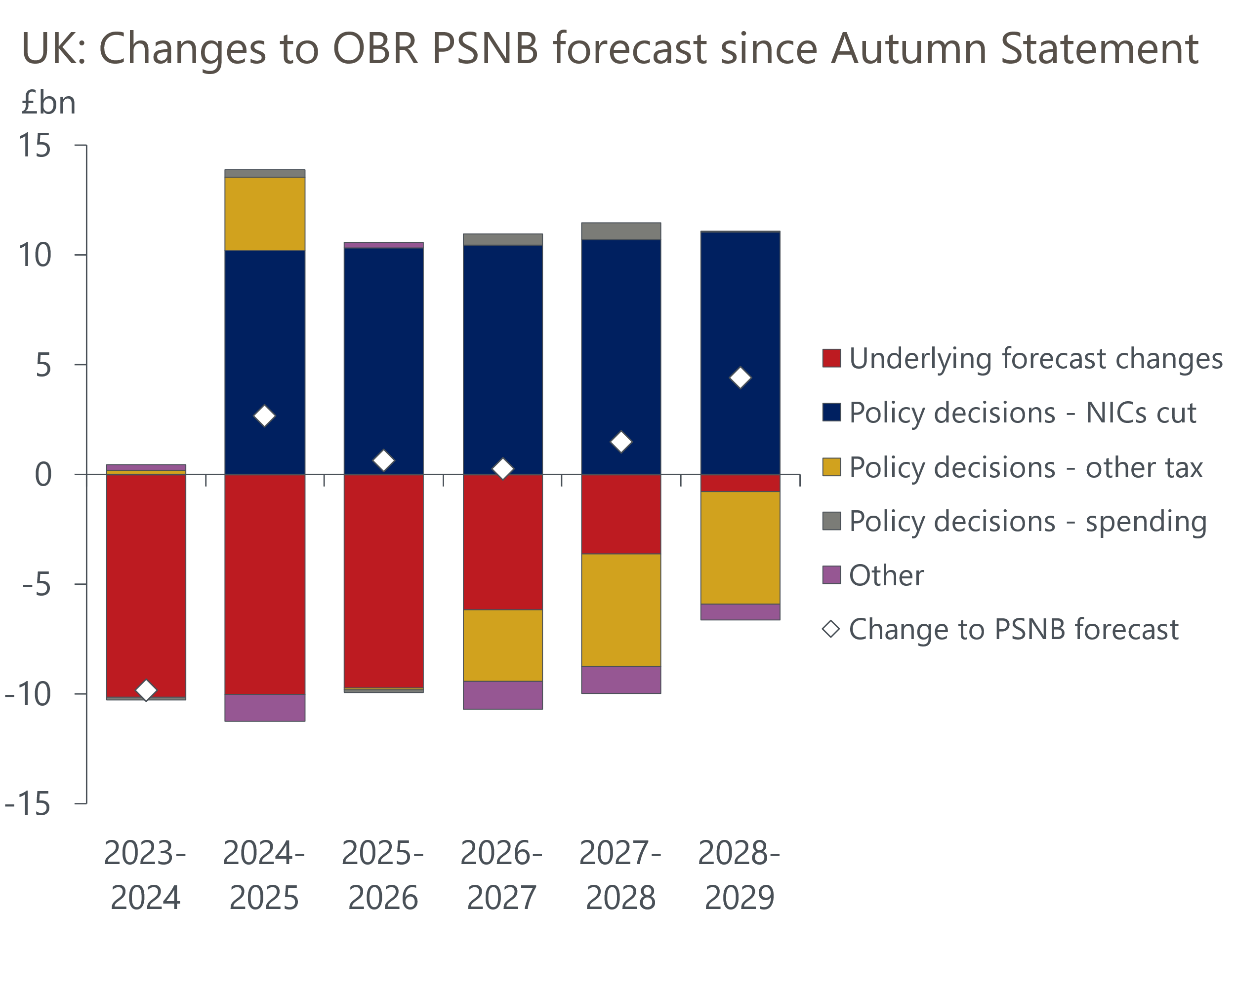
Source: Oxford Economics calculations using forecasts from OBR

The cut to NICs rates should raise household spending power by roughly £10bn a year. Therefore, we will nudge up our forecast for GDP growth in 2024 and 2025 when we publish our updated projections as part of our global update on March 12. But on the flip side, the additional drag on economic activity from the Chancellor's new post-election tax rises means we plan to cut our growth forecast further out.
Stepping back from the new measures, fiscal policy will exert a significant drag on GDP growth over the next five years. On the tax side, the cumulative effect of this week's cut in NICs rates, and the similar cut implemented in November's Autumn Statement, will only offset around half of the impact of the long-running freeze in personal tax thresholds and allowances.
With regard to spending, we had feared that the Chancellor might be tempted to game the fiscal rules and assume an even more severe post-election spending squeeze. Those fears were not realised, with the Chancellor leaving departmental spending assumptions unchanged in cash terms, meaning a minor rise in real terms spending compared to November given the OBR's lower inflation projections. However, this followed a progressive tightening in spending totals from previous fiscal events (Chart 2). Real departmental spending per head is assumed to be flat over the next five years. Factoring in the rising demands of the National Health Service and defence, this implies unfeasibly large real terms spending cuts for unprotected government departments.
Chart 2: Chancellors have repeatedly cut back on future departmental spending plans
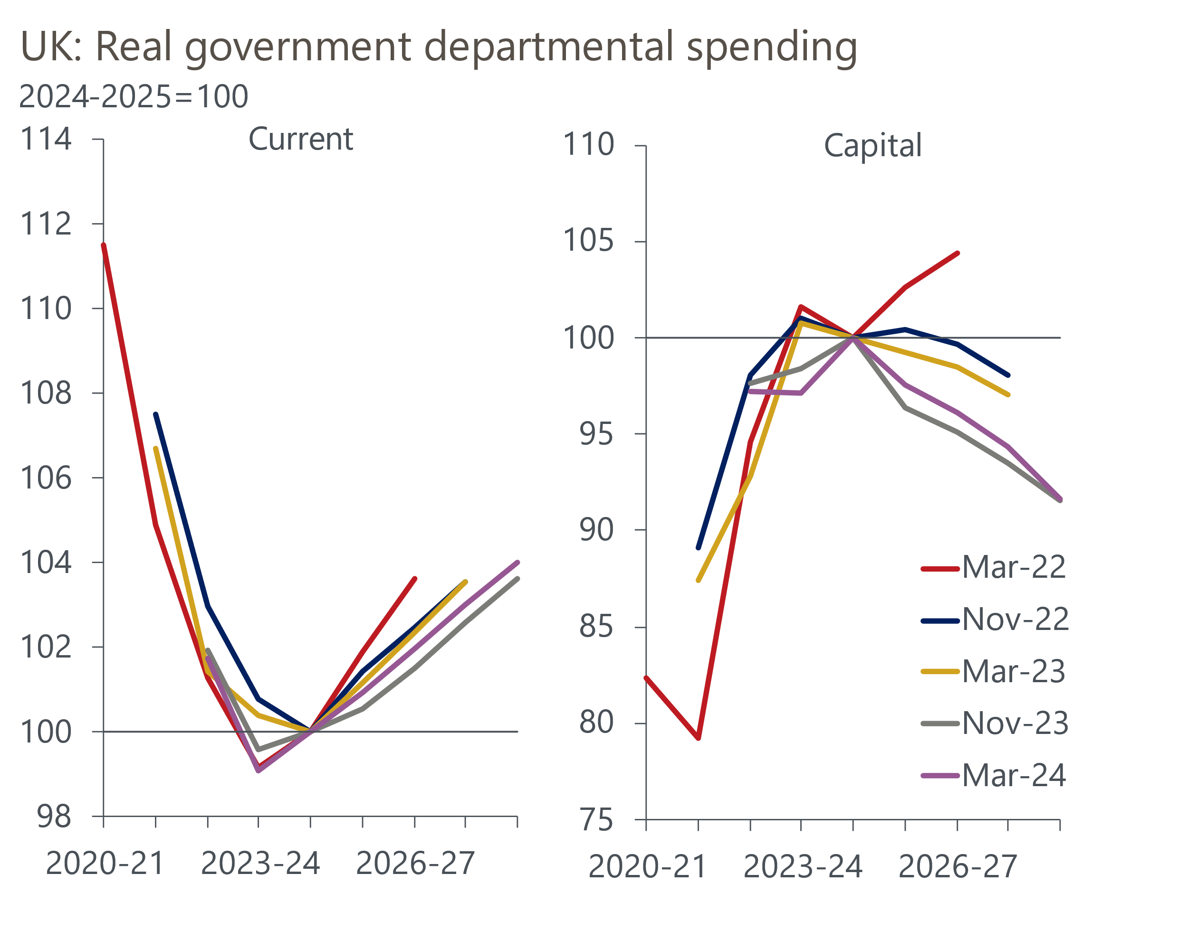
Source: Oxford Economics calculations using forecasts from OBR
Despite billing it as a "Budget for Long Term Growth", there was little evidence of much needed supply-side reforms which could boost potential output in the medium term. Hunt laid out £3.4bn of extra investment over the next five years on a new NHS productivity plan, aimed at ramping up digitalisation. But this was the latest in a long line of pledges to boost public sector productivity, while the bulk of the funding is set to come in after the general election, so it's hard to have confidence that this plan will be transformational. We made seven supply-side recommendations before the March 2023 Budget, but the three subsequent fiscal events have yielded material action in just one of those seven areas, namely reducing childcare costs.
By reducing the margin for error against the fiscal rules and continuing to pencil in unfeasibly large future departmental spending cuts, the Budget added to the challenges the next government will face, regardless of which party wins the election. With Labour planning to adopt similarly restrictive fiscal rules and responding to the Budget by talking about having to implement deep spending cuts if they win the election, the spectre of very tight fiscal policy dragging on growth looks to be baked in. But we think there's a better approach to this problem. We will publish a report next week that will set out our proposals for improving the fiscal rules, and show the results of our modelling that quantifies the impact that a new framework could have on growth prospects and key fiscal metrics.

The week ahead
Next week begins with the release of labour market data for January. Though the ONS' Labour Force Survey was re-introduced last month, the problem of small samples causing significant volatility will not be fixed for several months. This makes it hard to predict what the LFS data will show. Our sentiment-based indicator, developed in collaboration with Penta, suggests employment growth is gradually slowing. So, we think the jobless rate may have edged up slightly to 3.9% in the three months to January.
Meanwhile, our nowcast and the pay survey conducted recently by the Bank of England's regional agents suggest the downward momentum in pay growth in H2 2023 moderated in early 2024. We expect headline total pay growth to have slowed to 5.7% in January from 5.8% in December.
We expect December to have marked the low point for GDP. Part of December's weakness reflected a sharp drop in retail sales, which reversed in January. Meanwhile, business survey data also strengthened in January, with the S&P Global composite PMI reaching an eight-month high. Though NHS strikes are likely to have weighed on activity in the health sector again, we think GDP is likely to have risen 0.1% m/m in January.
Table 1: Week ahead calendar
Date | Events | Period | Measure | Unit | Previous | Forecast
Mar 12 | ILO unemployment | Nov-Jan | Rate | % | 3.8 | 3.9
Mar 12 | Average earnings (total pay) | Jan | 3m, y/y | % | 5.8 | 5.7
Mar 12 | Average earnings (regular pay) | Jan | 3m, y/y | % | 6.2 | 6.2
Mar 13 | GDP | Jan | m/m | % | -0.1 | 0.1
Mar 13 | GDP | Jan | 3m/3m | % | -0.3 | -0.1
Mar 13 | Index of services | Jan | m/m | % | -0.2 | 0.1
Mar 13 | Index of services | Jan | 3m/3m | % | -0.2 | 0.0
Mar 13 | Manufacturing output | Jan | m/m | % | 0.8 | 0.0
Mar 13 | Manufacturing output | Jan | y/y | % | 2.3 | 2.5
Mar 13 | Industrial production | Jan | m/m | % | 0.6 | 0.2
Mar 13 | Industrial production | Jan | y/y | % | 0.7 | 1.0
Mar 13 | Construction output | Jan | m/m | % | -0.5 | -0.1
Mar 13 | Construction output | Jan | y/y | % | -3.2 | -0.5
Mar 13 | UK trade | Jan | Trade balance | £bn | -2.6 | -3.0
Mar 13 | UK trade | Jan | Visible balance | £bn | -14.0 | -14.7
Source: Oxford Economics

Key forecasts
Table 2: UK forecast overview
(Annual percentage changes unless specified)
 | 2022 | 2023 | 2024 | 2025 | 2026 | 2027
GDP | 4.3 | 0.1 | 0.4 | 1.8 | 2.0 | 1.7
Private consumption | 4.8 | 0.3 | 0.6 | 2.2 | 2.2 | 1.8
Fixed investment | 8.0 | 2.9 | -2.8 | 0.4 | 2.6 | 2.2
Government consumption | 2.3 | 0.6 | 3.9 | 2.5 | 1.6 | 1.5
Exports of goods and services | 9.0 | -1.4 | -1.0 | 2.8 | 2.4 | 1.7
Imports of goods and services | 14.6 | -1.6 | 1.1 | 3.3 | 3.0 | 2.0
Industrial Production | -3.5 | -0.3 | 0.2 | 0.9 | 1.5 | 1.1
Consumer prices | 9.1 | 7.3 | 2.1 | 2.1 | 2.2 | 2.1
Unemployment rate (%) | 3.9 | 4.0 | 4.0 | 3.9 | 3.8 | 3.8
Current a/c balance (% of GDP) | -3.1 | -2.8 | -2.9 | -2.9 | -3.0 | -2.9
Government balance (% of GDP) | 4.4 | 5.2 | 3.3 | 2.6 | 2.0 | 1.4
Cen. bank policy rate (%, EOP) | 3.50 | 5.25 | 4.50 | 3.50 | 2.50 | 2.00
10yr govt. bond yield (%, EOP) | 3.67 | 3.54 | 3.76 | 3.46 | 3.02 | 2.85
Exchange rate (US$ per £, EOP) | 1.20 | 1.27 | 1.27 | 1.29 | 1.32 | 1.35
Exchange rate (euro per £, EOP) | 1.13 | 1.15 | 1.17 | 1.16 | 1.15 | 1.15
Source: Oxford Economics
Table 3: Quarterly forecasts for the UK
 | 2023 |  |  |  | 2024
 | Q1 | Q2 | Q3 | Q4 | Q1 | Q2 | Q3 | Q4
GDP (% year) | 0.3 | 0.3 | 0.2 | -0.2 | -0.2 | 0.1 | 0.5 | 1.2
CPI inflation (% year) | 10.2 | 8.4 | 6.7 | 4.2 | 3.4 | 1.6 | 1.8 | 1.8
Bank Rate (%, EOP) | 4.25 | 5.00 | 5.25 | 5.25 | 5.25 | 5.00 | 4.75 | 4.50
10yr gilt yield (%, EOP) | 3.47 | 4.39 | 4.46 | 3.54 | 4.00 | 3.86 | 3.81 | 3.76
US$ per £ (EOP) | 1.24 | 1.27 | 1.22 | 1.27 | 1.26 | 1.26 | 1.26 | 1.27
Euro per £ (EOP) | 1.14 | 1.17 | 1.15 | 1.15 | 1.17 | 1.17 | 1.17 | 1.17
Source: Oxford Economics

Latest Country Economic Forecast:
February 20, 2024

Recent publications

Data Insights
Services activity grew at a slightly softer pace in February
Manufacturing sector remained in a weak spot in February
Mortgage approvals rise, but net lending remains negative
PMIs signal stronger activity and price pressures
Extra fiscal headroom is looking more limited

Research Briefings
Hunt goes all-in on another NICS trim
Dissaving should give some aid to a consumer recovery
Lower inflation to support a gradual recovery in real incomes
Slowing labour supply puts the onus on productivity gains
Tight labour market and firm pay growth will worry the MPC

Contacts

Oxford Economics' UK team
- Andrew Goodwin - Chief UK Economist - agoodwin@oxfordeconomics.com
- Edward Allenby - UK Economist - eallenby@oxfordeconomics.com

